**The Challenge of delivering the 'D' in Transit Oriented Development: Examining the Town Planning contribution**

**Abstract**

This paper examines the extent to which different town planning approaches succeed in implementing transit oriented development (TOD). Of particular interest is the articulation of town planning policy through to implementation of development change on land around railway stations. A series of investigations include policy analysis and development mapping using Perth, Western Australia as a case study. This research found that development change has been slow despite long policy lead times and implementation has been inconsistent and patchy. Development planning for TOD has faltered, especially in relation to station precincts on new railways. Where development change has occurred the greatest success has been through use of public development agencies rather than through conventional planning approaches. Significant action in town planning is needed if development in is to be delivered to a greater number of station precincts across the metropolitan area.

**Keywords:** Transit oriented development; policy implementation; town planning

**Introduction**

Transit oriented development (TOD) provides a central focus where land use planning and transport planning would be expected to strongly interact. TOD is a development strategy being pursued in many city-regions worldwide. Typically TOD involves creating medium/high density areas of mixed land use concentrated within 800 metres walking distance of significant transit stops (Evans *et al.,* 2007). TOD aims to reduce car-based travel by offering alternative transport choices in the form of public transport, walking and cycling. On this basis, it is argued that TOD provides a more environmentally sustainable form of urban development by reducing the need to travel as well as facilitating a modal shift away from the car among TOD-based residents. TOD aims to strengthen the integration between public transport systems and urban development by creating places in which public transport is readily accessible for many activities.

There is some convergence in TOD policy approaches internationally (Curtis et al, 2009). In particular, TOD has been taken up in US cities as a way of counter-acting sprawl, with light and heavy rail the preferred transit technologies (Cervero, 1998; Bernick & Cervero, 1997; Dittmar & Ohland, 2004: Dunphy *et al*, 2005). In Australia, national policy seeks 'land use transport integration' as a means of achieving sustainable travel outcomes (DOTARS, 2003). TOD is seen as a principle means of achieving this integration and as such has been embraced in most Australian metropolitan strategies (Gleeson *et al*, 2004), including Adelaide, Brisbane, Gold Coast, Melbourne, Perth and Sydney. In the UK, attempts to link development more closely to public transport and close an institutional gap between land-use and transport planning have a long history. Current policy seeks to ensure “that new development is located where everyone can access services or facilities on foot, bicycle or public transport” (ODPM 2005: Para 27).

There a keen interest in a more coordinated approach to growth management to achieve a more sustainable urban form. In practice there are two situations, often occurring within the same city, each presents distinct challenges for implementing TOD. The first situation is where new urban growth can be framed around TOD; the second is where established urban areas can be re-structured to enhance TOD. In either of these situations a strategic planning framework and statutory planning base that requires development at the necessary intensity of use is essential to the success of TOD (Newman, 2009, Cervero, 2005). This is clearly the case in a wide range of case studies of TOD implementation around the world (see Curtis et al, 2009).

Research examining specific difficulties in implementing TOD is predominantly US focussed and concludes that implementation of the TOD concept has been patchy spatially (Dittmar and Ohland eds., 2004; Dunphy *et al*, 2005; Renne, 2005; Boarnet and Compin 1999). A number of policy implementation issues around town planning and TOD relate to the town planning challenge. Belzer et al (2004) and Renne (2005) argue that a good land use plan will provide developers with certainty and therefore encourage development implementation. Cervero (2005) contends that the presence of a bad land use plan or inflexible planning standards will be counterproductive. There is also a need to recognise that few cities start with a ‘blank slate’. Existing land use patterns may make TOD difficult, particularly where land parcels are in fragmented ownership (Boarnet and Compin, 1999).

The capacity of local and regional government to implement policy and invest in transport decisions has emerged as an important issue for transport policy in urban areas (EMCT/OECD, 2003). In many western European countries, the USA and Australia the trend has been to devolve decision making and resources to the local level. Given this direction it is important to examine the way in which public agencies are performing. Breheny, Gurney, and Strike, (1996) suggest the need to consider the influence of policy on decision making and the difficulties encountered in implementation. There is considerable interest in the difficulties associated with policy implementation both in relation to transport policy and specifically in relation to TOD. In relation to transport, Banister (2005) highlights the substantial difference between transport policy intentions and policy outcomes and identifies six barriers to implementation: resource; institutional and policy; social and cultural; legal; 'side effects' (effects of one action reduce the outcome of another action); and physical barriers in the transport. In this research paper the focus is on examining the first of these barriers: institutional and policy. Reitveld and Stough (2005) argue that one of the primary barriers to the delivery of sustainable transport is the institutional barrier. Such barriers can either reduce the potential of delivery, or make it impossible to achieve (Banister, 2005). North (1990) identifies the need to understand the rules and rule structures that guide action and the organisations as agents of those rules and the way in which they act. An analysis of the institutional barriers can provide for an exploration of the interactions between different levels of public sector policy, for it is here that the inability of one jurisdiction of government to effect the action of another presents a specific barrier (Ubbels and Verhoef, 2005).

The fragmentation and complexity of institutional environments can be a problem compounding implementation (Bajaracharya and Khan, 2005). To implement TOD requires strong integration and coordination between different public planning agencies. Strategic transport planners need to determine a public transport network that connects activity centres within the city in order to maximise public transport accessibility for travellers. Public transport planners need to devise a service pattern and frequency that enables people’s daily activities to be served by public transport. Highway planners have a role in designing street networks that facilitate multi-modal access to and within transit precincts. Town planners must rise to the challenge by identifying, at a metropolitan level, which activity centres should be designed around public transport accessibility, in order that they both support public transport patronage and maximise the network of opportunities to pursue daily activities. Town planners also have a role at a transit precinct level in ensuring higher density residential development and higher intensity non-residential development is planned for, facilitated and implemented. At the urban design level, town planners must pay attention to building orientation for accessibility and building design on its contribution to the street/place. Added to this there is a critical role market actors and the relationship between land use planners and the property market and developers.

**A conceptual framework for TOD policy implementation**

Barrett and Fudge (1981) provide the early insights into the issues of implementation. They conceptualise policy implementation as ‘putting policy into effect’ (p.4) describing the problem as one where “Governments ...appear adept at making statements of intention, but what happens on the ground often falls way short of the original aspirations” (p3). They contend that rather than this being the result of an unsuitable “bureaucratic structure“(p.4), implementation depends on knowledge of what to do, the availability of resources and the ability to marshal and control those resources, and on good communication (p.13). Bramley and Kirk’s (2005) more recent work emphasises the importance of understanding ‘context’. They suggest that when assessing the implementation of plans, the institutional context and the available planning tools must be considered together with the context in which the policy was formulated.

Two key theoretical frameworks for implementation are discussed in the literature (Barrett and Fudge, 1981; Ennis, 1997; Faludi, 2004; Albrecht, 2004; Altes, 2006): the concepts of ‘conformance’ (termed compliance by Barrett and Fudge, 1981) and ‘performance’ (referred to as a process of negotiation, or action and response by Barrett and Fudge).  ‘Conformance’ has its focus on assessing how well the plan is implemented in relation to the original intention. This is based on the assumption that the plan is the blueprint for the preferred solution and that any problems involved in the implementation of the plan arise because of conflicts in the hierarchical structure (managerial or organisational) of planning agencies. ‘Performance’ on the other hand, takes into consideration two key factors – stakeholders and time and the relationship between the two. The first factor, then, recognises that there are multiple stakeholders in the planning process and each may be at a different stage in the implementation process. Each stakeholder may also apply different measures to assess success of implementation.  The second factor relates to stages in implementation, drawing a distinction between formulation and implementation, although Hull *et al* (2007) comment on the difficulties of actually distinguishing such a stage. The impact of time is important, recognising that the knowledge available at the time the plan is implemented may be different to that available when the plan was formulated (particularly where implementation continues long after formulation). This later factor is further impacted where stakeholders change over time.

Drawing on the above understanding of implementation, this author contends that rather than being alternative viewpoints, the concepts of conformance and performance are complementary. It is possible to ask, first, how well the policy has been implemented, thereby considering conformance. Next, performance can be assessed by considering if there should be differing measures of successful implementation depending on other criteria such as place, time and the interaction with other stakeholders. This is the approach taken in this paper, asking: 1) Has State TOD policy been implemented, a) through translation from State to local policy, and b) through development change; 2) Should implementation success be measured differently by a) place (which station precincts should be TODs); b) time (taking into account the age of State and local policies; c) stakeholders (how has town planning implementation related to the actions of transport planners in building railway infrastructure).

**Research approach**

This research employs a case study approach, using Perth, Australia as the case. The case is appropriate because Perth has been one of the most deliberate attempts worldwide to move from car dependent development patterns to transit oriented development. Furthermore Perth has a long standing TOD policy, first introduced in 1988, and it would be reasonable to assess implementation given this timescale. In addition there have been three different town planning approaches to implement TOD: 1) conventional town planning process whereby State policy is translated to local policy and implementation depends upon private sector developer action; 2) Redevelopment Authorities where conventional town planning process is suspended; and 3) State as developer operating a quasi RDA model. This paper examines the extent to which these different approaches succeed in implementing transit oriented development (TOD). A series of research investigations are made:

1) A policy content analysis examines the articulation of state planning policies for TOD to the local government level. Implementation of local policy is then assessed by examining the extent of ‘on-ground’ development around all metropolitan station precincts.

2) A mapping analysis is made of land use in 2007 in Perth’s 68 station precincts. This is supplemented with information about residential and employee population in each precinct. This provides an examination of the implementation of TPS by development change.

3) An assessment is made of which town planning approaches are most effective in implementing TOD policy comparing the conventional state-local town planning approach with the state led development agency approaches.

4) The relationship between town planning action and transport infrastructure implementation is considered.

As noted above, implementing TOD requires the actions of many public agencies, both land use planning and public transport. The role of market actors (property market/developers) and local community are also key factors for successful implementation of TOD. It is not the intention of this paper, however, to examine all actors; instead this paper plays a deliberate role in examining one dimension – town planners. There is a need to provide an in-depth critique of the contribution of town planning to TOD. Rigorous monitoring of the implementation of town planning policy is rarely undertaken and the findings will show that changes to town planning practice are needed if effective and timely implementation is to occur.

**Planning Policy for TOD: Perth, Western Australia**

State planning policies requiring TOD around metropolitan railway stations are longstanding. In 1988 the State Planning agency began explicitly to direct land use decisions around railway station precincts. This town planning action coincided with a series of major transport infrastructure changes which began in the 1980s and have continued over the period since then. Three key ingredients in the TOD strategy are in place: the public transport network; the public transport service; and the strategic planning policy for TOD (Table 1).

**Table 1: The Perth TOD elements**

|  |  |  |
| --- | --- | --- |
| **TOD Element** | **Action** | **Timescale** |
| 1. Public transport network | Steady investment in public transport:  a) existing railway lines electrified  b) new railway line - northern suburbs  c) new orbital bus route linking ‘middle ring suburbs’& railway lines1  d) northern suburbs rail extended  e) new branch line added to eastern suburbs  f) new railway line – south-western suburbs | 1980s  1990s  1990s  2000s  2000s  2000s |
| 2. Public transport service | a) introduction of higher service frequency1  b) integration between bus and rail to reduce transfer times1 | 1990s  1990s |
| 3. Strategic land use policy | State-led planning policy requiring TOD:  a) *Development Control Policy 1.6 Residential Development near Metropolitan Railway Stations2 –*  - policy stipulated minimum densities of ‘R40’ (translates to a density of about 35 dwellings gross per hectare)  *superseded by*  b) *Development Control Policy 1.6 Planning to Enhance Public Transport Use3 –*  - ‘medium to high density’ remains but the actual density was no longer numerically stipulated,  - addition of considerations for bus routes within residential sub-divisions and need to optimise land use around high frequency bus routes  *superseded by*  c) *Development Control Policy 1.6 Planning to Support Transit Use and Transit Oriented Development –*  - “transit oriented precincts” defined - 800 m distance, for rail stations, transit interchanges or major bus transfer stations or terminals, and about 5-7 minutes walking time, or 400 m, for bus stops located on bus routes with multiple bus services that are high frequency of 15 minutes or less during peak periods’  - minimum density of 25 dwellings per hectare and the application of densities substantially higher than 25 dwellings per hectare where sites have the advantage of close proximity to a rail station, major bus interchange or bus route that provides service frequencies equivalent to rail  - significant generators of transit trips should be located close to transit facilities - including office and other ‘high-density’ employment-generating activities, intensive leisure facilities and retailing, aged persons development, schools and tertiary education uses, hospitals, community facilities and social services | 1988  1999  20054 |

Sources: 1 Department of Transport, 1998; 2 WAPC, 1988; 3 WAPC, 1999; 4 WAPC, 2005.

It is evident that there is and has been a strong suite of state government policies demonstrating clear intent for development around the metropolitan railway stations. This is not only found in the specific development control policy but also reinforced by reference to a wide range of other State policy documents[1] which focused on a sustainable future. The development control policy provides a means to articulate these higher order strategies into action through control of development.

***Implementation mechanisms***

The state planning agency expects implementation of the TOD policy to be achieved by requiring local governments to provide for such opportunities within their Town Planning Schemes (TPS). This expectation is one of ‘conformance’. The state planning agency is able to exercise control given its authority to recommend approval of the TPS to the State Minister for Planning. The mechanisms of state policy implementation are as follows. State planning legislation requires each local government to produce a statutory TPS for its entire area. The content of the TPS is dictated by a State planning agency guide, the Model Scheme Text (Government of Western Australia, 1999). TPS’s include a set of policies that will be used to determine applications for planning permission and building approval. In addition a land use zoning map and accompanying zoning table set out the type of land use and its residential density in specified locations. The TPS is required to conform to state planning policy, and is checked for compliance and consistency by this state agency and finally signed off by the State Minister for Planning. A further mechanism for implementation is provided through the decision process for sub-division of land. In this case it is the State planning agency that assesses sub-division applications which are then determined by the Western Australian Planning Commission and Minister. This structure provides strong vertical linkages for policy articulation and decisions.

In addition to the State’s strong control over all local government’s TPS and subdivision of land, it can influence the nature of development through its own land development agency, LandCorp, and the Department of Housing and Works (responsible for public housing). Further provision to facilitate development takes the form of area specific Redevelopment Agencies (RDAs). In 2001 the amalgamation of State transport and planning agencies into one super agency added a further capacity for the ability to integrate land use and transport. In 2001 after the election of the State Labor government the Department of Transport, the Ministry for Planning, and Main Roads Western Australia (MRWA) were amalgamated into the Department of Planning and Infrastructure (DPI). This new institutional arrangement required that they report to one Minister under the banner of Planning and Infrastructure (Gleeson, Curtis, & Low, 2003, p217). In theory this institutional change was to have generated better coordination between planning and transport infrastructure decisions and therefore better integration. In July 2009, after a change in government in 2008, the transport and town planning functions of state have again been separated.

**Findings**

***Implementation: Local planning policy intentions***

The core planning considerations indicated in State planning policy which would deliver TOD are density and intensity of land use. Local TPS zoning maps for each station precinct were analysed during 2007 to assess the extent of conformance with state policy (Table 2). Assessing conformance is not a straightforward task. First, a decision to compare the net or gross residential density with the state density requirement is needed. In this case net density (number of zoned dwellings by area of residential land parcel) rather than gross density (number of zoned dwellings by total area of station precinct) was applied given the potential for the station precinct to have uses other than residential. Therefore the assessment made is whether the land zoned residential is being utilised to full density potential. The second issue in assessing conformance is deciding which State TOD policy to measure against as many TPS have not been fully updated for years. Some TPS were written much earlier than the latest State policy (2005) and in some cases prior to the first State TOD policy in 1988; this despite a requirement for local planning schemes to be updated every five years. Just over half of the station precincts conformed to the 2005 policy (36 out of 68). Given the longevity of State policy interest in TOD this is cause for concern.

**Insert Table 2 here**

By taking the gazettal date of the TPS (the date at which a completely new scheme is written, relacing in entirety a prior scheme), since this represents the local authorities’ current policy position with regards TOD, it is possible to compare the density policy against the relevant State policy of the time (Figure 1). Across the four state policy periods TPS conformance has been variable, 30% of stations precincts were in conformance in period one (no State policy), increasing to 44% in period two. There was a reduction in conformance in period three (35% of precincts conformed to zoning policy); the 1999 State TOD policy did not proscribe actual densities. The majority of planning schemes cover this period giving this lack of conformance greater impact on implementation outcomes. The final policy period shows that all of station precincts conformed to the 2005 State TOD policy. It should be noted however that while this policy specifies a density it is lower than in the 1988 policy (see Table 1 for details).

An in-depth analysis of implantation performance must take into account a wider range of issues. A key issue is whether or not all station precincts should necessarily be TOD’s. State TOD policy provides no guidance on this; instead the policy is applied across to all stations regardless of their place and function within the region. The policy requires higher than baseline densities where service frequencies are 15 minutes or less, but railway lines run at this frequency during peak periods so this would suggest that all stations must be TODs. Turning to other State policies for guidance enables some indirect assessment of which station precincts could reasonably be expected to be TODs. The Metropolitan Centres Policy (1991) designated 5 Strategic Regional Centres. The policy promotes the need for good public transport accessibility to these centres but only designated retail floor space caps, it was silent on residential density. Only 3 of the 5 Centres conform to the TOD policy density. The 1991 Metropolitan Centres policy was superseded by a new Activity Centres policy (Government of Western Australia, 2010) and may give potential guidance on which precincts should be TODs (although the 2005 State TOD policy has not been rescinded). A hierarchy of 99 centres is established which includes classification of strategic, secondary and district centres. Of significance is that minimum residential density levels are set ranging from 20 - 30 dwellings per “gross” hectare depending on type of centre. The definition of gross density differs from previous definitions. It is defined as residential land zoned not including land for parks, public purpose and transport corridors – effectively a net density figure. Added to this explanation is a note that “net” densities would be likely to be two to three times higher – effectively a site density or residential footprint. This new policy applies to 36 of the 68 station precincts in Perth and these will be expected to deliver higher densities than those indicated in the 2005 State TOD policy. The implementation of the Activity Centres policy will require amendment of TPS. Figure 2 shows the 36 station precincts which are now designated in the 2010 Activity Centres policy and indicates which precincts have densities conforming to this policy. At the lowest level of the hierarchy 13 out of 16 of the precincts conform. At the other two levels fewer precincts conform, highlighting the need for expedited amendment of TPS.

The analysis thus far has focussed on implementation by state and local governments following the conventional planning approach. As with international planning practice, alternative public sector planning models have been adopted in Perth including the use of Redevelopment Authorities[2] (RDA) and public sector development agencies. Have these alternative models delivered any greater implementation success? Four precincts fall under the RDA jurisdiction, in all but one case density zonings have conformed to State TOD policy (Table 2). At Subiaco (Photograph 1), for example, the railway line was placed underground in 1998 so releasing new land which, coupled with adjoining vacant industrial land, has seen an additional 1,000 dwellings units and 70,000 m2 of commercial floor space developed by 2005 (Howe, Glass and Curtis, 2009). As an alternative to the RDA model WA has also employed a public sector developer to lead development change in two precincts - North Fremantle and Cockburn (Photograph 2): at the former site, 4 ha of land is being redeveloped for 500 apartments housing 1,000 residents, and at the latter, 12 ha of land is being developed for 1,000 dwelling units and civic uses (Mouritz and Ainsworth, 2009). Development had only just commenced at the time of the audit.

***Insert Photograph 1 here***

***Insert Photograph 2 here***

How effective has the implementation of TOD policy been where new railways have opened in Perth? This provides a measure of implementation performance considering the relationship with stakeholders, in this case the transport agency. A disappointing picture emerges (Figure 3). Eight stations on northern suburbs railway opened in 1993 are governed by two different TPS: one was gazetted eight years before the railway opened (and prior to the first State TOD policy) yet net densities conform; in the other TPS, gazetted after the 2005 State TOD policy, only one of the station precincts conforms. For the other new railway lines, no forward land use planning has taken place with the exception of one station precinct (Canning Bridge). Given the level of investment required to build new infrastructure and the long lead times for transport infrastructure planning, timely land use planning has not occurred and the infrastructure has not been capitalised on in this way.

Assessing implementation of the mixed use requirements of State TOD policy is not possible. There is no density equivalent for land zoned for employment purposes. This has implications for the way in which local government may implement high intensity employment in station precincts and for the ability of State government to monitor conformance to its policy. A study of non-residential land use change at three new station precincts sited on the new southern suburbs railway found that not all non-residential land uses were compatible with TOD principles, and comprised uses with five or fewer employees (Curtis and Mellor, 2011). The study also found that, despite town planners being fully aware of the new railway proposal, the TPS did little to facilitate appropriate non-residential development.

***Implementation: On ground development change***

There is some evidence of translation of the 20-year State TOD policy into local TPS. The second stage of this research assesses the extent of development change on the ground. There is on average an eight to ten year lead time between policy development and development completion[3]. An analysis of the station precincts provides a snapshot of development in 2007 (Figures 4a and 4b) using data for land use within precincts and census data for population and employment from the Australian Bureau for Statistics 2001. The size of the pie (800 metre potential walking catchment) is shown to scale in order to demonstrate the potential impact all stations could have in providing a walk-on patronage as envisaged by the TOD concept. Large parts of the metropolitan area are beyond walking distance of a railway station. It is particularly important, therefore, to maximise the land use intensity and mix around each station precinct both to maximise the access opportunities for residents and employees and to support public transport.

Within each station precinct land use is depicted as the proportion of land for residential, employment and ‘other’ uses (public open space for example). Up to one third of all precincts are underutilized from a development intensity perspective. The residential net density is indicated using three categories: low (less than 10 dwellings per hectare); medium (between 10 and 15 dwellings per hectare); high (greater than 15 dwellings per hectare). This latter category, although low by European standards, represented the highest density levels attained outside the Perth Central area at that time. It falls short of the 25 du/ha indicated in the 2005 State TOD policy. Of the seven precincts developed at higher densities only three were outside the Perth central area, and these are sited on the original suburban railway lines. The majority of precincts were developed at low densities (see Photograph 3). There is a clear density gradient - highest densities are close to the Perth central area, lowest in outer suburbs. The analysis using gross density showed a poorer result: 84% of station precincts had a density of less than 10 dwellings per hectare and only 1 station achieved a density greater than 15 du/ha (Maylands an inner suburb precinct at 18 du/ha). Implementation measured by conformance has been very ineffective.

***Insert Photograph 3 here***

Since the 1970s the State has promoted a planning policy for the development of regional centres at the ends of each railway. The planning rationale was that these regional centres would provide a counter balance to the Perth CBD for employment. Employment use (Figures 4a and 4b) includes a measure for intensity of employment using worker floor space density; low intensity uses (employing equal to or less than 1 person per 150 square metres); high intensity (employing more than 1 person per 150 square metres). Only thirteen station precincts outside the Perth Central area contain employment use, and only two of these are developed at the higher work floor space density. Out of the 5 regional centres at the ends of the railway, only one implements the employment policy, but only at low intensity worker floorspace.



**Figure 4a: Metropolitan Station Precincts: Actual land uses at 2007 (net density shown)**



**Figure 4b: Metropolitan Station Precincts- Perth CBD inset - Actual land use (net density shown)**

There would appear to be some evidence that station precincts governed by local planning schemes gazetted in the ten year period after the 1988 State TOD policy have translated to the delivery of higher density precincts: 30% of precincts are medium density compared to only 13% post 1998 (Figure 5).

**Figure 5: Gazettal date of scheme by Actual Net Residential Density category Station precincts:**

**Residential development at 2007**

0

5

10

15

20

25

30

Pre 1988

1988 – 1998

1999 – 2005

**Date scheme adopted relative to**

**State development control policy**

**No. precincts**

Actual Net density

<10 du/ha

Actual Net density

10 - 15 du/ha

Actual Net density

>15 du/ha

The state government objective of ‘planning to support public transit use must be considered in an international context. Calthorpe (see Bressi, 1994) recommends a gross density of 40 du/ha (this figure in addition to commercial uses within the precinct) as necessary to support public transport. Others have used a level of service specification for public transport to determine minimum residential densities required to support a particular service frequency (Table 3). Perth’s station precincts fall considerably short of all of these benchmarks (Figure 6).

**Table 3: The relationship between density and service frequency**

|  |  |  |  |
| --- | --- | --- | --- |
| **Service Frequency** | **Min. Residential Density Required (Units)** | | |
|  | Puskarev & Zupan, 19771 | Messanger & Ewing, 19942 | Dittmar & Ohland, 20043 |
| Bus - 1 hour service | 10/ha (4/acre) adjacent to corridor | N/A | N/A |
| Bus - 1/2 hour service | 17/ha (7/acre) adjacent to corridor | 19/ha (8/acre) | >12/acre (suburban neighbourhood) |
| Bus - frequent service (<15 mins) | 37/ha (15/acre) adjacent to corridor | >26/ha (>11/acre) | 48/ha (20/acre)  (urban neighbourhood) |
| Rapid Transit 5 minute headway in peak hour | 30/ha (12/acre) over extensive area with high density close to station | N/A | >144/ha (>60/acre) (hub of radial transport system – urban downtown) |

*(Sources: Ministry of Transportation and Ministry of Municipal Affairs, 1995 citing Pushkarv B S and Zupan JM (1977) Public Transportation and Land Use Policy; Messenger and Ewing, 1994 cited in Dittmar and Ohland, 2004; Dittmar and Ohland, 2004.)*

**Figure 6: Gross Residential Density – Perth Railway Stations compared to Calthorpe benchmark (shown as 40 dwellings per hectare)**



Newman and Kenworthy (2006) contend that for a station precinct to capitalise on its public transport accessibility and also offer the best efficiency for supporting public transport, a threshold of 10,000 employees and/or residents should be based in the station precinct. None of Perth’s stations reach this figure for residents alone; only 5 stations meet this benchmark on employees alone. The maximum number of dwellings in any one precinct was 3,645, the minimum 35 and the mean 1,237. The number of residents living in station precincts ranged between 18 and 5,995. The number of employees based within each precinct ranged between 0 and 59,012 with the mean at 4,118. Three quarters of all stations had less than 2,335 employees. The combination of residents and employees puts only 8 of the 68 stations within this benchmark; all are based within the inner suburbs (Figure 7).

**Figure 7: Numbers of residents and employees in station precincts at 2001 – only 9** **station precincts meet or exceed the Newman 10,000 rule (data is ABS 2001 Census).**

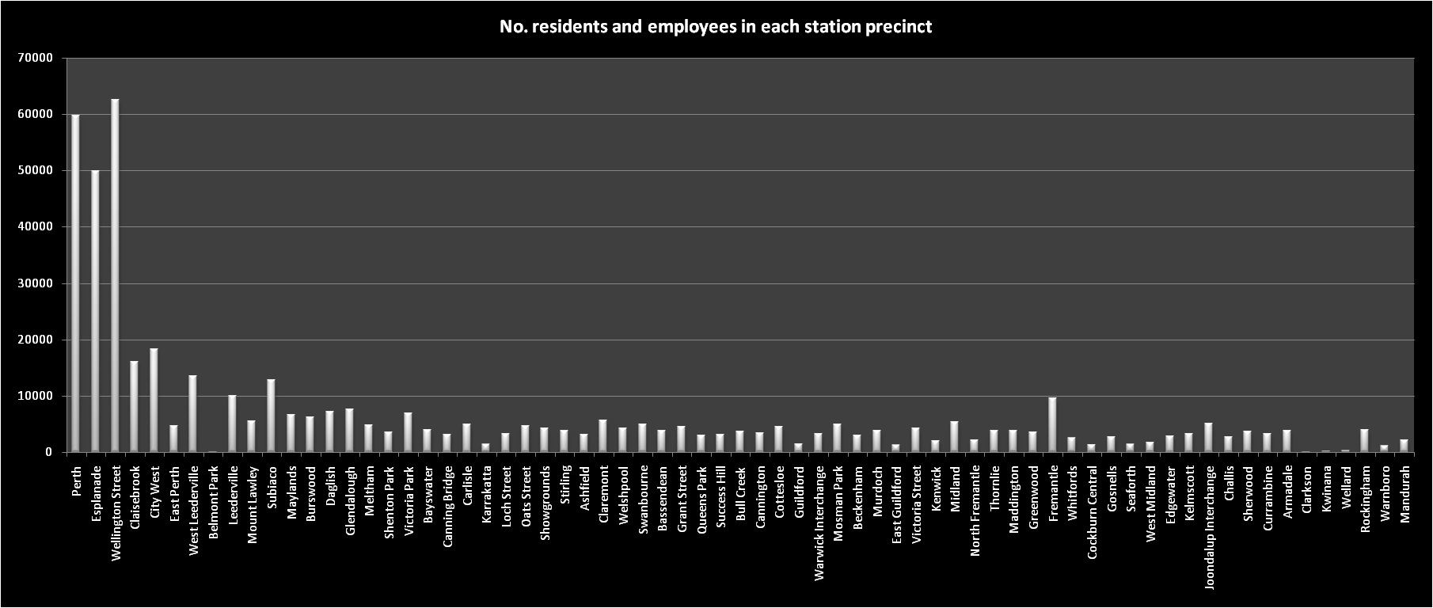

**Discussion**

This research is concerned with the question of whether the planning system can implement the ‘D’ in TOD - that is the development dimension of TOD. It is shown that there is clear national and state support for the broad principles of TOD. The State government have also embarked on an ambitious railway infrastructure development programme since the early 1980’s. There has been a long standing development control policy for TOD started in 1988. This policy is implemented through local TPS. These in turn are intended to facilitate development in station precincts. The State TOD policy requires higher residential densities and higher intensity employment uses in all of Perth’s 68 station precincts. Planning powers of State government in WA are strong yet there is limited evidence of their application in relation to implementation of TOD policy. Despite a 20-year policy, only one third of station precincts are governed by planning schemes that conform to State density zonings. Revisions of State policy over time have seen a shift from clear density prescription to a period where density was ill-defined. Where poorly defined policy is produced it is not easy to measure conformance. Even in the periods where State TOD policy has been prescriptive there are a number of local planning schemes that have not conformed to State policy. This is a puzzle given that State has the power to assess compliance of each TPS. Only in the last five years has the State TOD policy become more clearly articulated. There is evidence that this has been translated into the most recent TPS. Further research is needed to understand the effectiveness and rigour of the State assessment processes for TPS and issues for local government in expediting their TPS review.

The relationship of other State planning policy to the State TOD policy has been examined. It is evident that policies which specify the status and land use mix at activity centres have been in conflict with the State TOD policy, in some periods promoting differing density requirements for example. The latest revision to State policy (Activity Centres 2010) designates just over half of all station precincts as some form of activity centre where mixed use and higher density residential development is directed.

It is evident that only limited implementation, measured by development change, has occurred. Only seven of the 68 precincts had higher residential density development and all were in or close to the inner city. Many precincts are underutilized as regards development intensity. Where precincts do have conforming TPS zoned residential densities, the planning regulation has not stipulated that these must be complied with. The developer has been at liberty to develop residential land at densities lower than the given zoning.

While the conventional planning approach has delivered limited success, other models of implementation have offered a solution. Where RDAs have been established TOD policy implementation has been effective, yet these interventions are few compared to the total number of precincts and this limits the impact of TOD policy across the metropolitan area. Using an RDA model also limits the potential to develop local planning capacity. Where an RDA model is used, the agency acts as developer and the local government and community are removed from the planning process. Further research is needed in order to understand the interplay between local government, the property market, development industry and community in relation to the implementation of TOD using the conventional planning approach.

The research has shown that government is not entirely without capacity to implement TOD yet the effect on urban development by 2007, after a policy running over 20 years, has been modest and patchy. There is a significant ‘implementation gap’. There are important lessons for future planning for TOD. It would appear that action is necessary by State and local town planners and public transport planners. At the State level, the most recent 2005 TOD policy is prescriptive but there is ambiguity about density definitions and conflicts with the new 2010 Activity Centres policy. The introduction of minimum density standards will need to be monitored to see if this results in implementation or whether other incentives will be needed for the development industry to participate. Other state jurisdictions suggest offering incentives (see for example the 2002 California Statewide TOD study, BTHA and CALTRANS, 2002). State regulation and processes provide for TPS to conform to state policy. A key problem appears in the number of schemes that have not been fully replaced for many years. The regulation envisages schemes be fully updated every five years, by ensuring this is done content related to TOD precincts could be fully assessed.

The building of new railways and station precincts has offered new opportunity to implement TOD policy. It is evident, however, that TPS are not updated ahead of railway opening – a case of planners not planning ahead! There has been an ambiguity between railway planners and town planners about the function of some station precincts. The approach for new railways in Perth has been to focus on stations as transit interchanges whereby large car-based catchments can be drawn on rather than walking catchment (see Curtis, 2008 for details). Collaboration is needed between public transport planners and state town planners in order to consider the role and function of each precinct. There appears a serious shortcoming in the planning process which requires further research.

The empirical evidence clearly identifies an implementation gap but does not research the reasons for that gap. There are a number of possible explanations drawn from the author’s own experience of planning practice and research within the region. A further research agenda should examine:

* Why some local governments have not amended their TPS to conform with state policy;
* Why development has not taken place in station precincts – does this reflect a lack of interest by the development industry or unwillingness by local government to enforce policy, perhaps reflecting community opposition to development change?
* How else can the State support implementation of TOD beyond its policy mandate for TOD and the use of RDAs:
  + Would local government benefit from the provision of a model scheme text or design guidelines for station precincts?
  + What competency and skills exist for TOD implementation?
  + Would collaborative working between state and local planners on station precinct site planning assist (assuming resources are scarce for local planners).
  + What incentives and disincentives may be needed to ensure development takes place in station precincts? These might include, for example remediation of brown field sites and provision of other infrastructure.

**Acknowledgements**

This paper draws on research funding from two main sources: Australian Research Council Linkage Grant LP0562422 (including industry partners: Peet and Co, Department for Planning and Infrastructure WA, Public Transport Authority, Landcorp, Revelopment Authorities of East Perth, Subiaco, & Midland, Cities of Cockburn, Melville, Rockingham and Town of Kwinana); Volvo Research and Education Foundation grant funding for the Australasian Centre for the Governance and Management of Urban Transport. The author acknowledges the support of research assistance from Roger Mellor and Jake Schapper.

**References**

Albrechts L. (2004) Strategic (spatial) planning re-examined, *Environment and Planning B: Planning and Design* volume 31, pp. 743 - 758

Altes W K K, (2006) Stagnation in housing production: another success in the Dutch ‘planner’s paradise’? *Environment and Planning B: Planning and Design* 33(1) 97 – 114

Banister D (2005) *Unsustainable Transport: City Transport in the new century* Routledge: London

Bajracharya B & Khan S (2005) Planning for Sustainable transit oriented development: the case of SE Queensland, *Queensland University of Technology Research Week International Conference*, July 4-8.

Barrett S and Fudge C (1981) Policy and Action: essays on the implementation of public policy, Methuen:London.

Belzar D, Autler G, Espinosa J, Feigon S, & Ohland G., (2004) The transit oriented development drama and its actors, in Dittmar H & Ohland G *The New Transit Town*, Island Press: Washington DC.

Bernick, M. Cervero, R. (1997) *Transit Villages in the 21st Century* (New York: McGraw-Hill)

Boarnet MG & Compin NS (1999) TOD in San Diego County, *Journal of the APA*, Winter: 80-95

Bramley G, Kirk K (2005) Does planning make a difference to urban form? Recent evidence from Central Scotland, *Environment and Planning A* volume 37, pages 355-378

Breheny M, Gurney A, Strike J (1996) The Compact City and the Need to Travel: The implementation of UK Planning Policy Guidance in Jenks M, Burton E & Williams K 1996, *The Compact City: A Sustainable Urban Form?*, E & FN Spon, London.

Bressi T.W. (1994) 'Planning the American Dream', in *The New Urbanism: Toward an Architecture of Community*, ed. Katz P, McGraw Hill, New York.

[BTHA and CALTRANS] Business, Transportation and Housing Agency and California Department of Transportation, 2002, Statewide Transit-Oriented Development Study: Factors for Success in California

Cervero R (2005) TOD in America: strategies, issues, policy directions, *Transit Oriented Development: Making it Happen Conference*, Fremantle, WA 5-8 July

Cervero, R. (1998) *The Transit Metropolis: A Global Inquiry* (Washington DC: Island Press)

Curtis C and Mellor R (2011) Anticipating a new railway: the relevance of transit oriented development to businesses in a car orientated city *Urban Policy and Research* Vol 29 No. 1, pp1-26.

Curtis C, Renne J L, Bertolini L (eds) (2009) *Transit Oriented Development: Making it Happen* Ashgate, Aldershot

Curtis, C. (2008) Evolution of the Transit-oriented Development Model for Low-density Cities: A Case Study of Perth’s New Railway Corridor, *Planning, Practice and Research* Vol 23, No. 3 pp. 285 -302.

Department of Planning & Urban Development (1991) *Metropolitan Centres: policy statement for the Perth Metropolitan Region*, Department of Planning & Urban Development:Western Australia

DOTARS [Department of Transport and the Regional Services] (2003) *National Charter of Integrated Land Use and Transport Planning*, Department of Transport and Regional Services, Canberra.

Dittmar, H. and Ohland, G. (2004) *The New Transit Town. Best Practices in Transit-Oriented Development* (Washington DC: Island Press)

Dunphy, R., R. Cervero, F. Dock, M. McAvey, and D. Porter (2005) *Developing Around Transit: Strategies and Solutions That Work. (*Washington DC: Urban Land Institute).

EMCT/OECD [European Conference of Transport Ministers & Organisation for Economic Co-operation and Development] (2003) *Implementing Sustainable Urban Travel Policies: National Reviews*, OECD Publications Service, Paris.

Ennis F. (1997) Infrastructure Provision, the Negotiating Process and the Planner's Role *Urban Studies* 34: pp. 1935

Evans, I. V., J.E., Pratt, R. H., Stryker, A. & Kuzmyak, J. R. (2007) *Transit Oriented Development – Traveler Response to Transportation System Changes,* Transit Cooperative Research Program (TRCP) report 95, chapter 17 (Washington, DC: Transportation Research Board of the National Academies).

Faludi A.(2004) The Impact of a Planning Philosophy *Planning Theory* 3 p. 225-

Gleeson B, Darbas T, Lawson S (2004) Governance, Sustainability and Recent Australian Metropolitan Strategies: A Socio-theoretic Analysis. *Urban Policy and Research* 22 (4): 345-366.

Gleeson, B., Curtis, C., & Low, N. (2003). Barriers to Sustainable Transportation in Australia. In N. L. a. B. Gleeson (Ed.), *Making Urban Transport Sustainable* (pp. 201-219). New York: Palgrave Macmillan.

Government of Western Australia (1999) *Town Planning Amendment Regulations*,Perth, State Government of Western Australia.

Government of Western Australia (2003) *Hope for the future: the Western Australia state sustainability strategy,* Perth, State Government of Western Australia.

Headicar P (2004) The contribution of Land Use Planning to reducing traffic growth: the English experience, *European Journal of Transport and Infrastructure Research* **3**, no. 2, (2003), pp. 137-154 citing Oxford Brookes University and WS Atkins (1996) *The Land Use Effects of Planning Policy Guidance and Increasing Congestion* Report to the Department of Transport, UK.

Howe A, Glass G and Curtis C (2009) Retrofitting TOD and managing the impacts: the case of Subi Centro in *Transit Oriented Development: Making it Happen,* Curtis C, Renne J L, Bertolini L (eds), Ashgate, Aldershot.

Hull A, Tricker R, Forrester J and Snell C., (2007) *Understanding the Processes of Policy Delivery for Sustainable Urban Transport*, DISTILLATE: Formal Deliverable D1, accessed 19 August 2009 and available at <http://www.distillate.ac.uk/outputs/Processes%20Report_D1_final%20draft.pdf>

Ministry for Transportation and Ministry for Municipal Affairs (1995) *Transit-Supportive Land Use Planning Guidelines*, Ministry for Transportation and Ministry for Municipal Affairs, Ontario.

Mouritz M and Ainsworth L (2009) Successful Delivery Mechanisms: Coordinating Plans, Players and Action in *Transit Oriented Development: Making it Happen,* Curtis C, Renne J L, Bertolini L (eds), Ashgate, Aldershot.

Newman, PWG, 2009, Planning for Transit Oriented Development: Strategic Principles, in Curtis C, Renne J L, Bertolini L (eds) (2009) *Transit Oriented Development: Making it Happen* Ashgate, Aldershot

Newman, PWG. and Kenworthy, J. 2006, ‘Urban design to reduce automobile dependence’, *Opolis* 2:1, 35-52.

North D. (1990) *Institutions, Institutional Change, and Economic Performance*. Cambridge University Press, New York.

[ODPM] Office of the Deputy Prime Minister (2005) Planning Policy Statement 1, London: TSO.

Reitveld P & Stough R (eds.) (2005) *Barriers to Sustainable Transport: institutions, regulations and sustainability*, Spon Press, Abingdon.

Renne J (2005) Transit-Oriented Development in Western Australia: Attitudes, Obstacles and Opportunities. Research Report for the Planning and Transport Research Centre of Western Australia.

Ubbels B and Verhoef E (2005) Barriers to transport pricing, in *Barriers to Sustainable Transport: institutions, regulations and sustainability*, eds. Rietveld P. & Stough R. Spon Press, Abingdon, UK

[WAPC] Western Australian Government (2010) *State Planning Policy 4.2 Activity Centres for Perth and Peel*, State of Western Australia: Perth.

[WAPC] Western Australian Planning Commission, (2006) *Statement of Planning Policy No. 3: Urban Growth and Settlement*, WAPC:Perth

[WAPC] Western Australian Planning Commission (2005) *Development Control Policy 1.6 Planning to support transit use and transit oriented development*, WAPC: Perth, Western Australia.

WAPC [Western Australian Planning Commission (2004) *Network City: Community Planning Strategy for Perth and Peel*. WAPC, Perth, Western Australia.

[WAPC] Western Australian Planning Commission, 2001, Claremont Enquiry by Design Workshop, Government of Western Australia

WAPC [Western Australian Planning Commission] (1999) *Development Control Policy 1.6, Planning to Enhance Public Transport Use*, WAPC: Perth, Western Australia.

[WAPC] Western Australian Planning Commission (1988) *Development Control Policy 1.6 Residential*

**Table 2:** Comparison of Local Planning Scheme Zoned Residential Yield against State Planning Policy for TOD.

|  |  |  |  |  |  |  |  |
| --- | --- | --- | --- | --- | --- | --- | --- |
| ***State TOD Policy*** | **Local Planning Scheme@** | **Station Precinct** (status in regional centres policy hierarchy)$ | **Zoned Residential Density (net)1** | **Zoned Residential Density (gross)2** | **Net density conforms to State Policy3** | **Railway line opened** |  |
| ***1) No State policy on TOD in this period*** | Bassendean (1983) | Ashfield (4) | 21 | 5 | No | 1881 | Middle ring suburb – industrial area |
|  | Bassendean (4) | 24 | 13 | No | 1881 | Middle ring suburb |
|  | Success Hill | 19 | 8 | No | 1881 | Middle ring suburb |
| Swan (1985) | East Guildford | 5 | 1 | No | 1881 | Outer suburb |
|  | Guildford | 7 | 1 | No | 1881 | Outer suburb |
|  | Midland (2) | 70 | 10 | Yes | 1881 | Outer ring – regional centre, rail terminus. Redevelopment Authority |
|  | West Midland | 34 | 8 | No | 1881 | Outer suburb |
| Stirling (1985) | Glendalough | 51 | 20 | Yes | 1993 | Outer suburb |
|  | Stirling (2) | 49 | 20 | Yes | 1993 | Middle ring suburb |
| Nedlands (1985) | Karrakatta | 28 | 4 | No | 1881 | inner suburb with large cemetery |
| **2) State Development Control Policy 1.6 (1988)**  ***Minimum density R40 (equivalent 35 dwellings/ha)***  ***Mixed Use*** | Kwinana (1992) | Kwinana (3) | 20 | 4 | No | 2007 | Outer suburb |
|  | Wellard | 18 | 1 | No | 2007 | Outer suburb |
| Canning (1994) | Cannington (2) | 39 | 15 | Yes | 1885 | Middle ring suburb- Regional Centre |
|  | Queens Park | 35 | 18 | Yes | 1885 | Middle ring suburb |
|  | Thornlie (4) | 19 | 15 | No | 2005 | Middle ring suburb |
|  | Welshpool | 40 | 3 | Yes | 1881 | Middle ring suburb |
| Victoria Park  (1998) | Belmont Park (3) | 0 | 0 | No | 1885 | Middle ring suburb |
|  | Burswood (4) | 24 | 5 | No | 1885 | Inner suburb |
|  | Victoria Park (3) | 35 | 19 | Yes | 1885 | Inner suburb |
|  | Carlisle | 34 | 23 | No | 1885 | Middle ring suburb |
|  | Oats Street (4) | 35 | 16 | Yes | 1885 | Middle ring suburb |
| Cottesloe (1998) | Cottesloe (4) | 21 | 10 | No | 1881 | Inner suburb |
|  | Grant Street | 22 | 14 | No | 1881 | Inner suburb |
|  | Victoria Street | 32 | 10 | No | 1881 | Inner suburb |
| Vincent (1998) | East Perth | 55 | 14 | Yes | 1881 | Redevelopment Authority area |
| Cambridge (1998) | Leederville (3) | 60 | 17 | Yes | 1881 | Inner suburb |
|  | West Leederville (4) | 45 | 17 | Yes | 1881 | Inner suburb |
| **3) DC1.6 State Policy Revision 1 (1999)**  ***Required medium to high density but no numeric specification***  ***Added bus stations and routes in addition to railway station precincts*** | Melville (1999) | Bull Creek (4) | 24 | 17 | No# | 2007 | Middle ring suburb |
|  | Murdoch (s) | 23 | 14 | No | 2007 | Middle ring suburb |
| Claremont (1999) | Claremont (3) | 26 | 13 | No | 1881 | Inner suburb |
|  | Loch Street | 24 | 11 | No | 1881 | Inner suburb |
|  | Showgrounds | 24 | 14 | No | 1881 | Inner suburb |
|  | Swanbourne | 23 | 15 | No | 1881 | Inner suburb |
| Mandurah (1999) | Mandurah (2) | 20 | 15 | No | 2007 | Outer suburb – Regional Centre |
| Mosman Park (1999) | Mosman Park | 27 | 12 | No | 1881 | Inner suburb |
| Joondalup (2000) | Currambine (4) | 36 | 26 | Yes | 1993 | Outer suburb |
|  | Edgewater | 20 | 17 | No | 1993 | Outer suburb |
|  | Greenwood (4) | 20 | 20 | No | 1993 | Outer suburb |
|  | Joondalup (2) | 0 | 0 | No | 1993 | Outer suburb - Regional Centre (primarily retail) |
|  | Warwick (3) | 20 | 17 | No | 1993 | Outer suburb |
|  | Whitfords (3) | 20 | 20 | No | 1993 | Outer suburb |
| Wanneroo (2001) | Clarkson (3) | 0 | 0 | No | 2004 | New outer suburb |
| Subiaco (2001) | Daglish | 25 | 12 | No | 1881 | Inner suburb |
|  | Shenton Park | 19 | 6 | No | 1881 | Inner suburb |
|  | Subiaco (3) | 38 | 11 | Yes | 1881 | Redevelopment Authority area (1990s/2000s) |
| Gosnells (2002) | Beckenham | 23 | 13 | No | 1885 | Middle ring suburb |
|  | Gosnells (4) | 34 | 20 | No | 1885 | Outer suburb |
|  | Kenwick | 18 | 9 | No | 1885 | Outer suburb |
|  | Maddington (3) | 19 | 6 | No | 1885 | Outer suburb |
|  | Seaforth | 19 | 6 | No | 1885 | Outer suburb |
| Cockburn (2002) | Cockburn Central (3) | 20 | 3 | No |  | Outer suburb  Landcorp involvement |
| South Perth (2003) | Canning Bridge* (4) | 35 | 12 | Yes | 2007 | Middle ring suburb |
| Bayswater (2004) | Bayswater | 28 | 19 | No | 1881 | Middle ring suburb |
|  | Maylands (4) | 43 | 33 | Yes | 1881 | Inner suburb |
|  | Meltham | 30 | 24 | No | 1881 | Middle ring suburb |
|  | Mount Lawley (4) | 28 | 17 | No | 1881 | Inner suburb |
| Perth (2004) | Claisebrook (1) | 89 | 10 | Yes | 1881 | Redevelopment Authority area |
|  | Esplanade (1) | 160 | 1 | Yes | 2007 | Inner city |
|  | Perth Central (1) | 71 | 2 | Yes | 1881 | Inner city |
|  | City West (1) | 82 | 7 | Yes | 1881 | Inner city |
| Rockingham (2004) | Rockingham (2) | 20 | 16 | No | 2007 | Outer suburb – Regional Centre |
|  | Warnbro (3) | 27 | 10 | No | 2007 | Outer suburb |
| **4) DC1.6 State Policy Revision 2 (2005)**  ***Residential density set at 25 dwellings/ha or above – higher where in close proximity to high frequency public transport***  ***Requires high trip generating development*** | Armadale (2005) | Armadale (2) | 35 | 22 | Yes | 1885 | Outer suburb – Regional Centre  Redevelopment Authority area |
|  | Challis | 34 | 21 | Yes | 1885 | Outer suburb |
|  | Kelmscott (4) | 34 | 20 | Yes | 1885 | Outer suburb |
|  | Sherwood | 34 | 27 | Yes | 1885 | Outer suburb |
| Fremantle (2007) | Fremantle (2) | 39 | 5 | Yes | 1881 | Inner city - Regional Centre |
|  | North Fremantle (4) | 28 | 8 | Yes | 1881 | Inner suburb  Landcorp involvement |

Notes: TPS residential land zoning uses an ‘R Code’ to give an indicative residential density yield for that land parcel - Eg. a one hectare parcel zoned R20 would theoretically be permitted to develop up to 20 dwellings. In practice, due to other planning controls concerning dwelling setbacks, provision of private open space and so on, only about 75% of the given ‘density’ will be achieved if fully built. As a rule of thumb R20 deliver a maximum of 15 dwellings per hectare. The audit assumed zoned land would be developed at maximum density, representing the full potential. Where the zoning map permits a ‘dual R Code’ the assumption the higher density was applied.

@ Planning Scheme date is the latest gazetted date and includes all amendments to the scheme since gazettal is therefore the latest version at time of research audit conducted in 2007. An old date indicates the scheme has not been entirely replaced and can contain up to 100 amendments. Most schemes were amended between 2005 and the 2007 audit date.

$ Activity Centres Hierarchy (1) Primary Centre – Perth CBD; (2) Strategic Centre; (3) Secondary Centre; (4) District Centre

1 net density calculated as dwellings/ residential land parcel.

2 net density calculated as dwellings/ whole precinct of 201 ha.

3 for Planning Schemes gazetted prior to first State TOD policy compliance is assessed retrospectively against the 1988 policy.

# Conformance assessed against densityfigure for 1988 policy given none specified in 1999 policy.

* Station precinct straddles local authorities of Melville and South Perth.

**Photograph 1: Subiaco Station precinct developed using an RDA model** (station in background centre, mixed use residential, retail, cafes shown).

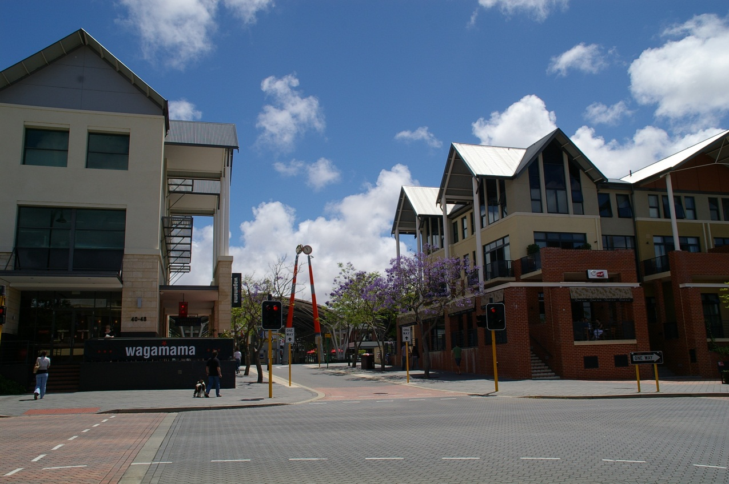

**Photograph 2: Cockburn Central Station precinct developed using a public sector development agency model** (station, bus interchange and car park in background right, apartments under construction, left)

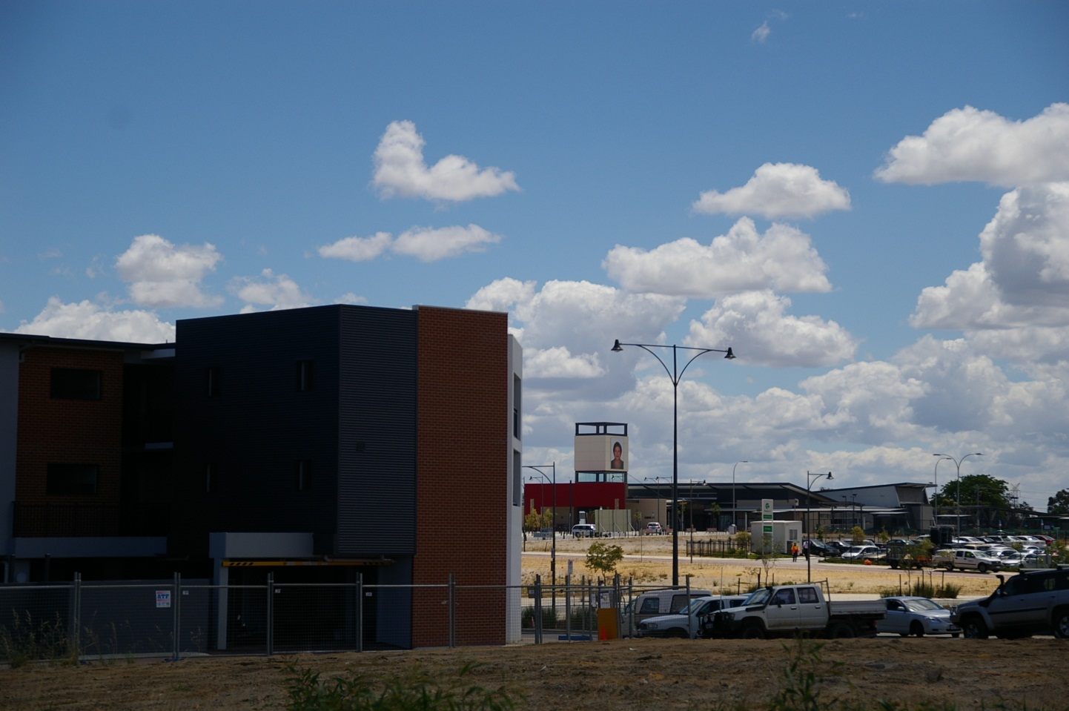

**Photograph 3: Bayswater Station precinct governed by a conventional planning model** (station to the right - off picture)



1. The State Sustainability Strategy (Government of Western Australia, 2003); a new metropolitan planning strategy (WAPC, 2004); a statutory policy, Statement of Planning Policy 3 Urban Growth and Settlements(WAPC 2006b).
2. The State government has powers to establish a Redevelopment Authority in a designated area. In such places, local planning powers are suspended with the State government playing a greater role in both planning policy and in directly facilitating development.
3. See Headicar P (2004) citing research carried out by this author and a team in the UK. This holds true in Australia – in 2000 an Enquiry by Design for Claremont (WAPC, 2001) started a process of planning for the development of mixed use higher density development adjacent to a railway station – the development was opened for business in 2011.